Class Assesment

- HTTP is readable because it is a text based unencrypted protocol

- HTTPS is unreadable because it uses secret mathematics codes to lock data before it leaves the PC.

- The ports used are port;
Source port:80
Destination port:65232

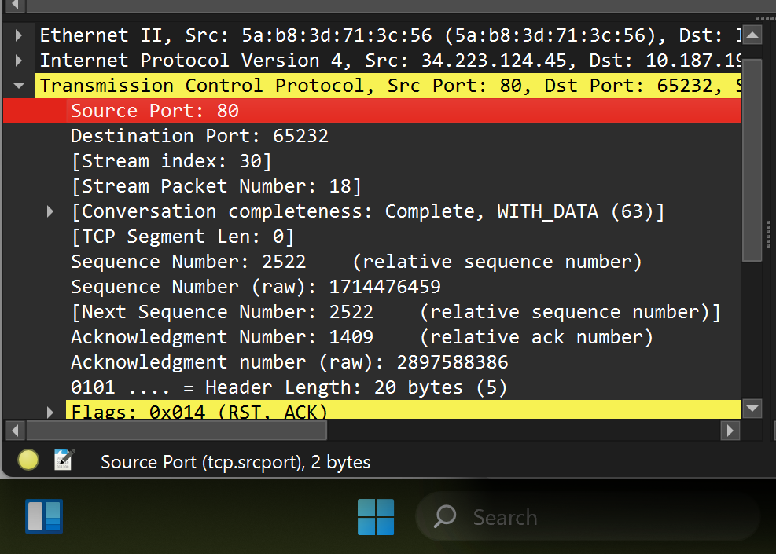

4.

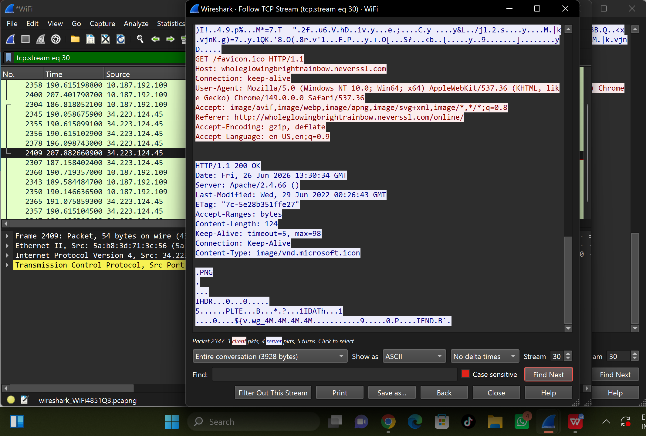

5. During TLS Handshake.Your computer sends a "Client Hello
The server replies with a "Server Hello

6.Because it does not possess the secret session keys required to unlock the data

